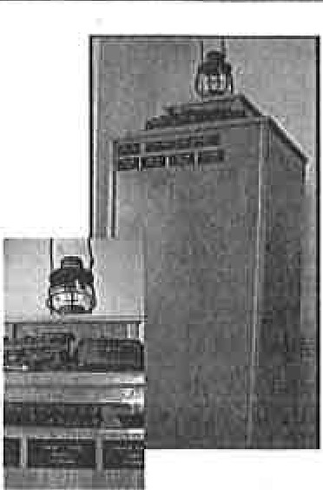
Hornell Erie Depot Museum
is proud to present the new
HEDM Memorial to
Honor the
Men and Women of the Railroad
Support your Museum and Honor your Railroad Family and Friends

To order your $25 memorial plate fill in forms below and mail with payment (cash or check only)to:
Your name: _
Address: _
Phone (in case of questions):
-----------
Email: _

Hornell Erie Depot Museum P.O. Box 5 Hornell, NY 14843
To support your museum please add additional:
$5.00_ $10.00_ $15.00_ Other_

Remember a loved one on the HEDM Memorial
L
Your $25.00 memorial plate is 2" x 4"
Three lines: NAME, JOB TITLE and RAILROAD(s)

Print NAME in capitals allow for spacing and punctuation 20 letter maximum:

Print JOB TITLE in capitals allow for spacing and punctuation 20 letter maximum:

Print RAILROAD(s) in capitals allow for spacing and punctuation 20 letter maximum:

